**Contents**

1. The green transition as a pathway for a sustainable future 2

1.1 New political context and priorities 2

Competitiveness of the green transition 3

1.2 Time for urgent action: the green transition as response to global challenges 4

Tipping points: the need for accelerated actions 5

The impact of climate change on health 6

The costs of inaction 9

1.3 What people think about the green transition: the social perception of the EGD 13

1.4 Where we are: progress towards green ambitions 14

1. The green transition as a pathway for a sustainable future
   1. Introduction

Since its launch in 2019, the European Green Deal (EGD) has made **significant progress** in driving the EU's transition to a low-carbon economy. The European Commission’s President has reaffirmed her commitment to the green transition, emphasising the **need to stay the course on the goals set out in the European Green Deal,** which remains a blueprint for fostering economic resilience, social cohesion, and global leadership. The implementation of the green transition is however increasingly facing various new challenges. The EU grapples with rising geopolitical conflicts and unprecedented trade tensions leaving it increasingly isolated on the world’s stage, slow economic growth and technological competition. Whilst the green transition supports **the redefinition of the EU’s competitiveness and security agenda,** the political, economic, social and regulatory frame in which it is analysed is shifting.

To this aim, aligning **sustainability** with **competitiveness** is essential for the EU’s strategic future: this is the way forward, also in light of the **new priorities set by the Commission, including** the EU’s new **Competitiveness Compass**, which points towards decarbonisation, closing the innovation gap, reducing energy dependencies and increasing security. Achieving the green transition requires not just **environmental progress** but economic resilience—a balance necessary to meet rising global tensions and competition [2][3][4]**.** Addressing this challenge calls for a **comprehensive approach** that integrates sustainability into the EU’s economic framework. The integration of **sustainability** and **competitiveness** serves as the guiding framework for this evaluation, drawing on evidence from key **reports** and **policy documents** that emphasize an adaptive, **innovation-driven approach** to the **green transition**.

The JRC report **"Delivering the EU Green Deal - Status of targets implementation"** notes that while progress has been made in aligning policies with the EGD’s objectives, implementation gaps persist . This work is an important piece of the puzzle in understanding where the EU stands, and underscores the need for enhanced coordination, targeted investment, and policy cohesion.

Building on these findings, this report aims to identify what is needed to bridge the remaining gaps and accelerate progress. It takes a look at the challenges ahead and dives deeper into existing barriers to implementation. It unveils potential enablers to foster progress towards the EU’s green transition goals and better assess the state of the green transition in the EU. This report also provides an integrated environmental assessment of XXX able to inform measures needed to address the evolution of production and consumption patterns, by estimating their overall life cycle related impacts.

….

Recognising that combining **sustainability** with **competitiveness** is essential for the EU’s strategic future, this report provides a **roadmap** for aligning the **EGD** with evolving economic conditions. This ensures that the EU can progress towards its **climate neutrality goal** while maintaining a **competitive edge, building resilience and ensuring social fairness.**

* 1. New political context: the green transition as a driver for competitiveness

The EU’s current political agenda, framed by the **Strategic Agenda 2024-2029** [1], underscores the central role of the **European Green Deal (EGD)** in steering Europe towards sustainable development and economic resilience. This renewed focus is driven by the pressing need to respond to evolving global challenges, including geopolitical tensions, shifting economic power dynamics, and the accelerating impacts of climate change. The EGD continues to be central to the EU’s strategic framework, integrating climate action with economic growth, ensuring that Europe remains at the forefront of green technology and innovation.

The importance of the EGD in supporting Europe’s competitiveness and sustainability is reinforced by findings in **“The Future of European Competitiveness”** reports [2] [3], which stress that the green transition is more than an environmental imperative; it is a fundamental component of Europe’s economic strategy. Achieving climate neutrality by 2050 and a 55% reduction in greenhouse gas emissions by 2030 are core objectives that require a dual approach: fostering innovation and securing economic autonomy. The EU’s ability to maintain its **strategic autonomy**, especially regarding critical raw materials and technological capabilities, is key to navigating competition from major global economies such as the United States and China, as current global dynamics have intensified competition. The United States and China, key global players, have been strategically investing in green and digital technologies that drive economic leadership. For instance, the U.S.’s Inflation Reduction Act has directed substantial investments towards renewable energy and sustainable industries, positioning it as a formidable competitor [3] [4] [5]. Similarly, China’s targeted policies in clean technology and supply chain dominance in critical minerals pose a significant challenge to the EU’s ambitions. These developments highlight that while the EGD provided a framework for Europe to lead in sustainable policy, maintaining that leadership demands continuous innovation and strategic investments.

Investment initiatives under the **EU Innovation Fund** and research programs within **Horizon Europe** are instrumental in supporting breakthrough technologies and advancing sustainable solutions that contribute to energy resilience and green infrastructure. For instance, funding allocated to renewable energy projects and the modernization of grid systems not only supports decarbonisation but also bolsters energy security—an increasingly critical concern in the current geopolitical climate.

The **Strategic Agenda 2024-2029** emphasizes resilience and strategic autonomy as foundational elements of Europe’s green transition. This involves strengthening the EU’s internal capacity to source materials sustainably, enhancing circular economy practices, and fostering industrial growth that aligns with the EGD’s environmental goals. The path forward requires not just strategic planning but tangible implementation steps that ensure consistency across the EU.

.

The EU must continue to strike a balance between **climate ambition** and economic strategy as it advances the EGD’s next phase. This includes not only maintaining the momentum of current efforts but also ensuring that adaptation and resilience measures are adequately supported.

**Competitiveness of the green transition**

The EU must now focus on bolstering its capacity to compete on a global scale by aligning sustainability with economic objectives. **Economic fragmentation** and regulatory differences among member states pose significant challenges to the uniform implementation of the EGD’s targets [6] [7]. Addressing these issues involves harmonizing policy measures, fostering cross-border initiatives, and reinforcing shared strategic goals. This coordination ensures that member states with fewer resources can keep pace with wealthier nations, creating an integrated approach that upholds EU-wide progress.

A critical aspect of the EU’s strategy is securing resilient and sustainable supply chains, particularly for raw materials essential for renewable technologies [1], [2]. The reliance on non-EU countries for key resources, such as lithium and rare earth elements, exposes vulnerabilities that could disrupt progress in the green transition. Policies focused on responsible sourcing, recycling, and fostering a **circular economy** are now more than sustainability measures; they are strategic imperatives for economic independence and stability. The development of partnerships within Europe and with trusted global allies is necessary to secure these supply chains and reduce reliance on geopolitically sensitive sources.

Energy independence remains a cornerstone for enhancing economic competitiveness. The EU has made significant strides in deploying renewable energy projects, supported by initiatives such as **Horizon Europe** and the **EU Innovation Fund** [8][9]. These programs have catalyzed important advancements in clean technology and energy efficiency, but scaling them up is crucial. Investments in modernizing grid systems and developing energy storage technologies are essential to handle the variability of renewable energy sources and ensure energy security. The challenge lies in implementing these strategies uniformly across member states while maintaining economic balance and avoiding exacerbating existing disparities.

The integration of digital and green transitions is pivotal for Europe to maintain productivity and competitiveness. Digital technologies, when combined with sustainable practices, can enhance efficiency and resilience in sectors ranging from manufacturing to energy management [10] [11] [12]. Initiatives that focus on smart grids, digital energy platforms, and AI-driven resource management underscore the EU's commitment to an innovation-led approach. However, fostering an environment that encourages rapid technological adoption and supports startups and research institutions is key to staying competitive in a landscape where technological prowess increasingly determines economic power.

The path forward for the EGD emphasizes not only sustainability but also strategic economic growth that secures Europe’s position in a competitive world. Ensuring that the benefits of the EGD are widespread requires robust public-private partnerships, targeted investments, and comprehensive policy support that includes subsidies, tax incentives, and funding mechanisms adapted to current needs. Equitable access to these resources can help bridge the gap between member states and promote cohesive action.

To meet these competitive challenges, the EU must not only sustain but amplify its focus on resilience and strategic autonomy. A continued emphasis on **cross-border cooperation and coordination**, investment in cutting-edge technologies, and regulatory reforms that streamline innovation will be critical [13] [9]. The EGD must evolve as a dynamic tool that can respond to both economic and geopolitical shifts, ensuring that Europe leads not just in environmental stewardship but in economic strength and adaptability.

By embedding resilience into the EGD framework, Europe can navigate external pressures while fostering growth and inclusivity. This strategic balance is essential for maintaining competitiveness and positioning the EU as a strong, sustainable force capable of meeting its ambitious climate and economic targets.

* 1. Time for urgent action: the green transition as response to global challenges

Climate change, environmental degradation, and social inequality are intertwined crises that demand a comprehensive response. The green transition is the necessary response and vital opportunity to these challenges, but it must be pursued in a way that balances environmental protection and climate action with social justice. Rather than being seen as a costly burden, the green transition can be a catalyst for EU competitiveness, driving innovation and growth while ensuring a sustainable and equitable future. This chapter explores the imperative of urgent action, highlighting the critical thresholds beyond which irreversible damage will occur, the health impacts of climate change, and the staggering "costs of inaction" for both the climate and biodiversity. By examining the interplay between negative and positive tipping points, we can unlock a new narrative for the green transition, one that harnesses its potential to transform the EU's economy and society for the better.

**Tipping points: the need for accelerated actions**

**Global Tipping Points** are critical thresholds, mostly related to temperature, at which **small changes can lead to dramatic shifts** in the state of fundamental Earth Systems such as land/water ecosystems, glaciers, atmospheric elements, and ocean currents (Tipping Systems). Increases in CO2 and its associated global warming are the major forces behind Tipping Points, but a growing number of co-drivers such as deforestation, ocean acidification, pollution, water eutrophication, albedo, extreme weather events, ecosystem fragmentation, overfishing, etc., are known to be pushing the Earth Tipping Systems into irreversible, self-sustained, destabilization processes that will lead to their eventual collapse.

The latest [Global Tipping Point Report](https://global-tipping-points.org/) identified more than 50 potential Tipping Systems. Empirical evidence suggests that at least up to 15 Tipping Systems are now actively responding to global warming (Lenton et al. 2009, McKay et al. 2022). Six out of them have their expected Tipping Points close to 1.5 °C (Figure 2): Greenland Ice Sheet, Western Antarctic Ice Sheet, Coral Reef Systems, Boreal Permafrost, Barents Sea Ice, Labrador Sea-Subpolar Gyre Convection. Tipping Points for regional Coral Reefs are now feared unavoidably crossed for the Caribbean and its Mesoamerican Reefs, and the remaining Tipping Systems are seeing their temperature thresholds decrease year after year.

Global tipping points present substantial biophysical impacts that can affect Europe in various ways. From the melting of Arctic ice and the Greenland ice sheet to disruptions in the AMOC, boreal forest dieback, permafrost thaw and Mediterranean desertification, the continent faces numerous challenges. These impacts not only threaten Europe's natural environment but also its economic stability, public health, and social fabric. Addressing these challenges requires the understanding of the risks and impacts of Tipping Points to support the formulation of precautionary and anticipatory strategies, which can then lead to innovative adaptation strategies. The number one anticipatory strategy remains, however, the **urgent commitment to reducing greenhouse gas emissions to avoid crossing these critical thresholds**.

On the other side, **positive tipping points** can drive substantial progress towards sustainability. These are transformational milestones in societal change that become self-reinforcing and accelerated, and have the potential to catalyze shifts in behavior, norms, and practices that collectively drive progress towards a more sustainable future.

Several positive social tipping points have been identified whose achievement can reinforce Europe's green transition , including:

1. **Renewable Energy Adoption**: The widespread adoption of renewable energy sources such as wind, solar, and hydro, driven by increased awareness of climate change and government policies like Germany's Energiewende.
2. **Sustainable Transportation**: The preference for sustainable transportation, including electric vehicles, cycling, and public transportation, driven by government incentives and cultural changes like the normalization of cycling in cities like Copenhagen.
3. **Circular Economy Practices**: The rise of the circular economy, which involves reducing waste, reusing materials, and recycling products, driven by consumer demand and initiatives like zero-waste stores and sustainable fashion movements.
4. **Youth Activism and Education**: The emergence of youth-led climate activism, epitomized by movements like Fridays for Future, and the integration of sustainability into education curricula, which shapes societal norms and policies.
5. **Digitalization and Smart Technologies**: The integration of digitalization and smart technologies in everyday life, which enhances resource management, reduces emissions, and fosters a culture of sustainability.

Leveraging these tipping points is crucial to drive systemic change and accelerate the transition towards a more sustainable future; they demonstrate the collective power of individual and societal actions in achieving the green transition

**The effects of climate change on health**

Climate change is a major stress to the environment, hence on the connected organisms it hosts such as microorganisms, plants, animals, and humans. Consequences of climate change are thus global, multifaceted and far-reaching by definition. Because it is modifying the current behavior of living organisms and pushing them beyond their physiological limits more often, climate change can have major and long-lasting impacts on all living organisms on the planet. Already in 2015, WHO, stated that “*Climate change is the greatest threat to global health in the 21st century*”. Later in July 2023, for the first time in history, **climate crisis and related extreme weather events** were declared a **public health emergency** by the WHO Regional Office for Europe. In fact, accordingly to the World Economic Forum (WEF), by 2050 climate change is likely to cause an additional 14.5 million deaths and $12.5 trillion in economic losses worldwide including $1.1 trillion in extra costs to healthcare systems 1,2. In tackling the causes and mitigating the consequences of climate change, it is central to adopt an integrative strategy, as environment, animals and humans are tightly connected (i.e. the **One Health approach**). Effects of climate change on health are numerous (see Figure 1), and include:

**Direct impacts**

* **Heat Stress**: As temperatures globally rise, heat stress becomes a major concern, particularly for vulnerable populations such as the elderly, young children, and those with pre-existing medical conditions. Heat stress can lead to heat exhaustion, heat stroke, and even death.
  + In Europe, heat waves are estimated, despite the inconsistent reporting, to have caused between 77,000-129,000 excess deaths between 1980 and 2020 3. Only in the summer of 2003, between 40,000 and 70,000 excesses of heat-related deaths occurred in Europe 4,5. Again, the warmer summers of 2022 and 2023 resulted in similar estimations for Europe, being respectively 61,672 and 47,690, the heat-related deaths 6,7. In Europe, between 1980 and 2023, 95 % of the deaths associated with weather and climate-related extremes were due to heatwaves 8.
  + A study published in The Lancet found that heat-related mortality in Europe could increase by 20-30% by 2050 if greenhouse gas emissions continue to rise 9.
  + The heat-related mortality has increased around 30 % in the past 20 years, and it is estimated to increase in 94 % of the nearly 1,000 European regions monitored.
  + By 2050, heat waves are expected to claim approximately 1.6 million lives worldwide, 65+ years-old citizen being the most susceptible 10.
* **Extreme Weather Events**: Climate-related disasters, such as hurricanes, wildfires, and floods, typically result in displacement, physical injuries, and loss of lives. These events can also have long-term effects on mental health, including anxiety, depression, and post-traumatic stress disorder (PTSD):
  + Floods are considered as the highest risk of acute climate-induced mortality, potentially accounting for 8.5 million deaths by 2050 worldwide, according to WEF 1,2.
  + Droughts, the second cause, with an estimated 3.2 million deaths as consequence of reduced access to food and water security and the increase of dust concentration, therefore also increasing respiratory diseases 1.
* **Air Quality**: Climate change is linked to poor air quality (pollutants such as PM2.5, PM10, O3, NO2, SO2), which can exacerbate respiratory conditions like asthma and chronic obstructive pulmonary disease (COPD), but also cardiovascular disease, particularly for those with pre-existing conditions and lung cancer. In Europe, each year around 300 000 people die prematurely due to air pollution 11. By 2050, levels of SO2 and NO2, are expected to rise 90% and 50%, respectively 12 and half of the world’s population will be affected by allergies and asthma 13.
  + Accordingly, to OECD, just the PM10 pollution is estimated to be responsible of 3.1 million deaths worldwide by 2030 14. Furthermore, just in the EU, the average life expectancy is estimated to be reduced by 8.6 months due to the PM2.5 exposure 5.
  + **Asthma and Respiratory Issues**: Asthma affects over 30 million people in Europe. Since climate change and higher CO2 levels are linked to increased pollen production 5, it can exacerbate allergies and respiratory issues like asthma. The above-mentioned pollutants such as PM2.5, PM10, O3, NO2, SO2 have been shown to have an inflammatory effect on the airways of susceptible subjects increasing permeability and therefore facilitating the interaction with cells of the immune system 5. For example, some studies estimate that sensitization to ragweed will increase from 33 to 77 million people, by 2041–2060 in Europe 15.

**Indirect Impacts**

* **Food and Water Scarcity:** Changes in temperature and precipitation patterns can lead to crop failures, reduced food availability, leading to food insecurity, as well as decreased water quality. This can result in malnutrition and micronutrient deficiencies, particularly for vulnerable populations. The increase of heatwaves and droughts events in 2021 was associated with 127 million more people experiencing moderate or severe food insecurity than in the period 1981–2010, with the consequent risk of malnutrition and potentially irreversible health effects 16.
* **Vector-Borne Diseases**: Climate change is altering the distribution and prevalence of disease vectors like mosquitoes, ticks, and fleas. This can lead to the emergence or re-emergence of pathogens, and increased risk of diseases like malaria, dengue fever, and Lyme disease, to name just a few.
  + Accordingly, to the ECDC, the number of locally acquired dengue cases has steadily increases, from 71 in the period 2010-2021, to 71 cases just in 2022 alone and 130 cases in 2023. The number of outbreaks is also increasing from 3 outbreaks per year between 2010-2017, 5 in 2018, 7 in 2020, 10 in 2022, and 14 outbreaks in 2023 17.
  + By 2050, an additional 500 million people may be at risk of exposure to vector-borne diseases (i.e., malaria, dengue and Zika) 18. Studies indicate that just in Europe, the risk of malaria transmission could increase by 10-20% by 2050 if climate change continues 1.
* **Water-Borne Diseases**: Changes in precipitation patterns, sea-level rise, and increased flooding can contaminate water sources, spreading water-borne diseases like cholera and diarrhea.
  + **Antimicrobial Resistance (AMR)**: AMR, also declared by WHO, one of the top ten global public health threats facing humanity that claims about 700,000 lives per year and it is estimated to cost between $300 billion to $1 trillion per year by 2050 19. Despite the main reason for AMR is the excessive and inappropriate use of antibiotics, climate change can exacerbate it since: a) bacteria growth and reproduction are facilitated by temperatures above 30° C 20; b) flooding can cause wastewater and sewage, the major vehicles of AMR in surface waters, to overwhelm treatment plants and contaminate surrounding areas 21,22, (i.e., AMR genes were reported in Svalbard and also deep in the oceans 23); c) the biodiversity loss diminishes the richness of plant species that might hold the key to new treatments against resistant bacteria 21. Some associations between *E. coli*, *S. aureus*, *P. aeruginosa* and *K. pneumoniae*, which main route of transmission is water-borne transmission, and climatic hazards have been reported 23.
* **Mental Health**: Climate change can have a profound impact on mental health, from anxiety and depression to PTSD and suicidal ideation. The stress of living in a rapidly changing environment can be overwhelming, particularly for those who have experienced traumatic events 24. These effects pose threats particularly for vulnerable groups with limited coping capacities (adolescents, young adults, elders) and those with pre-existing mental disorders.
  + According to WEF, the mental health effects, particularly PTSD, of climate change events are estimated on $275 billion and 58 million DALYs worldwide 1. Generalized anxiety, associated with droughts, is projected to cost $198 billion to the health system and impact 176 million DALYs worldwide 1.
  + Another study indicates that for every 1 °C increase in temperature there is an associated 2.2% increase in mental health-related mortality and 0.9% increase in morbidity 25.
  + One year after a flood in England, 36% of the regional population suffered from PTSD, around a quarter suffered from anxiety disorders and a fifth from depression 26.
  + In the case of the recent DANA of Valencia region (Spain) it is estimated that 20-25 % of the population of the destroyed ground zero will suffer different forms of post-traumatic stress. In addition, the post-traumatic stress raised to 70-80 % among those that have seen death-bodies, those feeling intense guilt for having survived or not been able to help more, and those previously in treatment 27.
* **Permafrost issues:** thawing of permafrost can also impact human health through the following main pathways 28:
  + Release of trace elements (e.g. metal contaminants) and major ions, previously stored in the permafrost, into water sources with the subsequent health consequences (i.e., cancers, developmental and reproductive disorders, cardiovascular and skeletal diseases, and neurotoxicity).
  + Release of previously contained pathogens, including antibiotic-resistant bacteria and unknown viruses. The risk of preserved pathogens being active after thawing is low, yet the consequences of their release are difficult to predict 290. For example, a 2016 outbreak of anthrax in Siberia is reportedly associated with the thawing of the permafrost and exposure of a reindeer carcass infected with anthrax long ago 30.
  + Release of chemical and radioactive waste stored in industrial sites located on degrading permafrost.

Globally, climate change is likely to exacerbate existing health inequities by affecting the **social determinants of health**, such as access to **clean water**, sanitation, and **healthcare**. **Economic losses**, and decreased productivity will obviously affect agriculture, food prices, and availability, thus challenging **global food systems** that will be more likely to be disrupted. This may lead to **social instabilities**, and in some countries, to malnutrition and food insecurity. Consequently, more **migration and displacement** are expected. This, in turn, can lead to more social, economic, and health problems, including higher stress levels among populations of Member States, increased (re)emergence and circulation of **pathogens**, higher vulnerability to disease, while society at large is expected to exhibit a decreased access to healthcare.

Figure 1. Scheme summarizing the different impacts of climate change in health

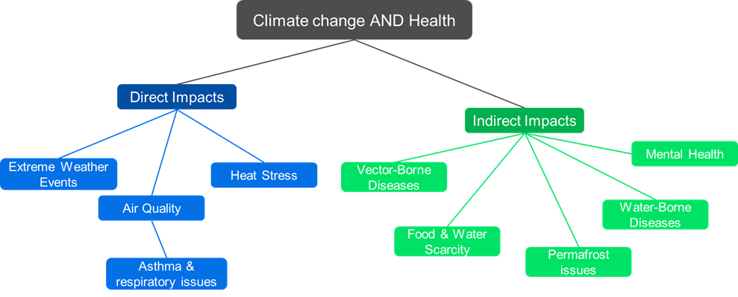

**The costs of inaction**

The **"costs of inaction"** refer to the economic, social, and environmental consequences of not taking measures to address climate change and environmental degradation. When assessing climate change and environmental policies, a comprehensive approach that accounts for both the costs and benefits of action and inaction is necessary. Such an approach allows for better informed decision-making, helps prioritize actions that minimize the risks and consequences of climate change, and can serve as a powerful motivator for individuals, organizations, and governments to take urgent and collective action to address the climate crisis and protect the environment. Moreover, considering the costs of inaction can also help to identify opportunities for cost savings and economic benefits associated with taking action.

Climate-related costs of inaction

To better understand costs of inaction, the pan-European climate risk assessment PESETA is published since 2007 regularly by the JRC, covering a wide range of climate impact categories. The methodology integrates a combination of state-of-the-art process-based and empirical models that translate high-resolution projections of climate conditions into biophysical and economic impacts. The cost of inaction refers to the simulated climate damages without any policy action, i.e. without adaptation or mitigation policies.

This section identifies projected damages under a 3°C global warming scenario as the “cost of inaction”. For few impact areas, 4°C scenario damages are also reported. Economic damage estimates consist of climate impacts that would occur by the year 2100. The JRC study provides results regarding climate impacts on people, the environment and the economy, with both biophysical and economic metrics. The consistent results summarised below refer to the eleven **JRC PESETA IV project impact areas** (human mortality from heat and cold waves, windstorms, water resources, droughts, river flooding, coastal flooding, wildfires, habitat loss, forest ecosystems, agriculture and energy supply) and the follow-up studies (e.g. labour productivity). In spite of the wide coverage, it is important to underline that the assessment does not consider other potentially important impacts and, therefore, provides a **lower bound** of the potential cost of inaction for Europe.

Preliminary results of the **JRC PESETA V** project are presented in figure 1, representing the additional economic costs (as a percentage of GDP) for the 2°C scenario by 2050 for the following impact areas: coastal floods, droughts, labour productivity, river floods, transport infrastructure, windstorms and energy demand. The burden of climate change shows a clear north-south divide, with southern regions in Europe impacted relatively more and, particularly, southern-eastern regions. That spatial pattern is due mainly to consequent changes in high-end temperatures and the spatial and temporal availability of water.

**Figure 1.** Additional economic costs for 2°C scenario by 2050, as a share of GDP (coastal floods, droughts, labour productivity, river floods, transport infrastructure, windstorms and energy demand)

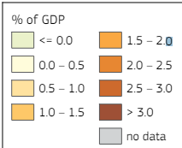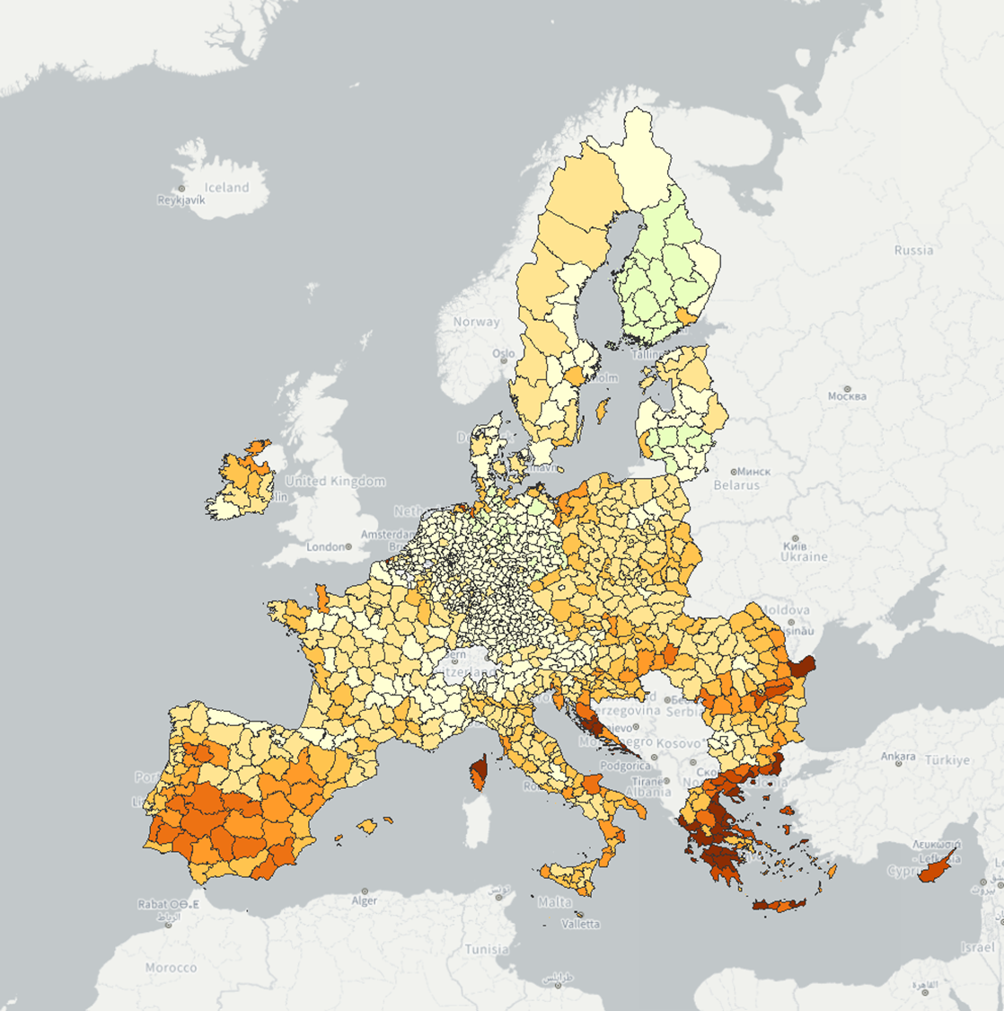

*Source: 9th Cohesion Report, European Commission (2024)*

The main results for the 3°C temperature degree scenario follow, unless otherwise stated.

*Climate impacts on people*

* Temperature-related deaths could increase by around 55,000 additional deaths by 2100, driven by rising heat-related deaths and an ageing population. Climate change is also expected to widen disparities in regional mortality, particularly impacting southern regions of Europe as a result of a marked increase in heat-related deaths.
* Around 450,000 people would be exposed to river flooding each year, or nearly three times the number at present.
* 1.4 million people would be exposed per year to coastal inundation compared to around 70,000 at present, i.e. a 20-fold increase.
* An additional 15 million Europeans living in the proximity of wildland would be exposed to high-to extreme fire danger for at least 10 days/year.
* Water resources availability would drop by up to 40% in Southern regions of Europe and droughts would happen more frequent in most of Southern and Western Europe.

*Climate impacts on the environment*

* The Alpine tundra domain would contract by 84% and practically disappear in the Pyrenees. The natural climatic tree line would shift vertically up by up to 8 m/year.
* Ecological domains would shift northwards, resulting in severe changes of the prevailing domains in southern Europe and Boreal areas and the encroachment of the Tropical domain in Europe.
* Wildfire and pest outbreaks will become more frequent and severe, increasing biomass loss and additional carbon release (and warming).

*Climate impacts on the economy*

* River flood losses would rise 6-fold in magnitude, reaching 43 €billion/year with 3°C.
* Coastal flood losses would grow by two orders of magnitude and climb to 200 €billion/year, from 1 €billion today.
* Drought losses would increase to nearly 41 €billion/year with 3°C warming (60 €billion/year with 4°C warming), compared to around 8 €billion/year at present.
* Water scarcity and drought would increasingly affect agriculture, energy production and water supply in regions that already suffer from water stress.
* Labour productivity could be 0.7% lower in Europe, compared to nowadays.
* There would be a regional redistribution of tourism demand within Europe, with also relative reductions in summer and increases in the shoulder and winter seasons.

Key impacts not considered in the JRC PESETA assessment include those related to the irreversible damage to nature and species losses, aquatic and marine ecosystems, water- and vector-borne diseases, air quality, displacement of people, conflicts and security, and the potentially daunting consequences of passing climate tipping points. The extent of extreme events are also not fully captured, such as those of heat stress on crop yields and droughts on energy production. Cascading climate effects across sectors and from the rest of the world are also poorly understood.

As mentioned above, this implies that the biophysical and economic impacts reported in PESETA represent just a lower bound of the cost of inaction for Europe. Furthermore, the assessment does not consider other fundamental cost categories indirectly associated to climate inaction: high energy supply vulnerability (notably higher energy import bill and the associated potentially large macroeconomic costs in terms of economic growth, inflation and employment), higher air pollution and security issues (e.g. migration). PESETA did not consider them despite their importance as they are not directly related to climate change impacts.

Biodiversity related cost of inaction

On top of the cost associated to a delay in preparing the EU to climate change, there is a considerable “cost of inaction” when it comes to protect and restore biodiversity. In fact, nature provides benefits to people and economy through ‘ecosystem services’ – such as the pollination of crops, protection of coasts from flooding and erosion, supply of fresh water, wood production, marine fisheries and carbon sink and storage. As the natural assets (such as forests, wetlands, coral reefs and seas) that provide these services decline, the economic burden on societies increases (including GDP, trade, and production and commodity prices).

Financial resource to protect and restore the planet’s more fragile natural resources currently amounts to $166 billion per year globally (for comparison, less than one-sixth of the annual investment in the greening of the energy system[1]), but it will need to increase to about $1 trillion globally by 2030[2]. While this is a sizable sum, it pales in comparison to the anticipated economic cost of biodiversity loss by the end of the decade. Even by the World Bank’s conservative estimates, the deterioration of natural processes like wild pollination and resources like marine fisheries could see global GDP come in $2.7 trillion a year lower than projected levels by 2030.  
Similarly, a detailed report[3] by WWF concluded that, “unless we reverse nature loss, trillions of dollars” (globally) “will be wiped off the world’s economies, industries will be disrupted and the lives of millions will be affected”.

The study calculated the reduction of supply of six ecosystem services in a ‘Business-as-Usual’ scenario, which would lead to an annual loss of US$ 479. Over the period between 2011 and 2050, the total cumulative loss would be US$ 9.87 trillion (3% discount rate). These figures should be considered highly conservative and should not be considered an assessment of the total costs of nature’s loss, since the current model only considers six of the many ecosystem services provided by nature (those for which there is enough evidence to quantify). Nor does it account for the potential effects of ‘tipping points’.

As a consequence of a decrease of ecosystem condition and hence in ecosystem services, the world’s agricultural sectors will be hardest hit by the loss of nature’s benefits, and the prices of several basic commodities will increase.

In Europe, biodiversity is in rapid decline and the economic picture is aligned with the global one. Economists estimate the [loss of biodiversity in Europe costs the EU around 3% of GDP per year](http://ec.europa.eu/environment/nature/biodiversity/comm2006/2020.htm) and global [biodiversity loss is valued at around €50bn](http://www.ieep.eu/assets/395/copi_final_report_jun.pdf). Crop pollination alone is [worth more than €14bn annually](http://www.cost.eu/COST_Actions/fa/Actions/FA1307), while [wetlands provide an estimated €6bln in ecosystem services](http://www.ieep.eu/assets/395/copi_final_report_jun.pdf) each year[4].

Acting to restore and conserve our natural environment is clearly a worthwhile investment and should be thought of as a “cost.” Failure to act would, however, come with a significant price tag for the economy and society.  For example, managing the Natura 2000 network requires an investment of around €5.8bn per year, but it generates [€200bn to €300bn per year in economic benefits](http://ec.europa.eu/environment/nature/natura2000/financing/docs/ENV-12-018_LR_Final1.pdf), according to European Commission figures.

Ensuring more effective implementation of EU Nature Directives at national and regional level, and placing greater importance on the value of our natural capital, as aimed in the EU Regulation on Nature Restoration, would have considerable benefits for biodiversity, sustainable economic development and Europe’s prosperity.

To this goal, t*he Biodiversity Finance Factbook*[5] identifies six overriding tasks that governments, companies, and financial institutions must address:

* Back initiatives to collect and share biodiversity data and harmonize metrics and frameworks.
* Integrate biodiversity into planning, operations and reporting.
* Reform environmentally-harmful subsidies and boost biodiversity support.
* Develop replicable business models and use concessional funding to address the dearth of bankable biodiversity projects.
* Improve the environmental integrity of offsets and other mechanisms.
* Promote industry and local community buy-in.
  1. What people think about the green transition: the social perception of the EGD

Public sentiment plays a critical role in shaping the success of the EGD: to understand the evolving perceptions of this transformative agenda, the JRC carried out an analysis of 582,156 Twitter/X posts from January 2020 to March 2024. By focusing on contributions from EU-affiliated accounts (23,413 tweets) and non-EU-related accounts (558,743 tweets), the study uncovers clear patterns in how different stakeholders engage with various stages of the EGD's implementation.

**Public perception of the EGD has evolved significantly through distinct implementation phases**, shaped by both policy developments across multiple sectors and external events. Analysis reveals that while general support for environmental and economic transformation remains strong, specific policy measures often face resistance when their immediate socio-economic impacts become apparent. The predominance of neutral sentiment (61.68%) in public discourse, compared to positive (28.26%) and negative (10.06%) reactions, indicates a crucial window of opportunity for policy communication and stakeholder engagement.

Temporal trends reveal four distinct phases in public perception. During the *announcement phase* (2020), cautious optimism prevailed, with positive sentiment peaking at 29% following the launch of the European Climate Law and key strategies such as *Farm to Fork* and *Biodiversity*. In the *delivering phase* (2020–2022), positive sentiment climbed further to 32%, bolstered by comprehensive packages like "Fit for 55," which demonstrated the impact of concrete, well-communicated policies. However, the *acceleration phase* (2022–2023) exposed vulnerabilities, with geopolitical events like the Russian invasion of Ukraine shifting discourse. Negative sentiment rose to 18%, driven by energy security concerns and uncertainties surrounding systemic transitions. Most recently, the *adoption phase* (2023–2024) underscored progress as initiatives like COP28 elevated positive sentiment to 33%, even if sectoral disruptions, including the farmers' protestsin early 2024 drove negative sentiment spikes up to 22%.

Thematic analysis underscores specific drivers of public sentiment. *Positive sentiment* often aligns with policies demonstrating tangible environmental and health benefits, such as improved air quality or biodiversity restoration, and those fostering economic opportunities through renewable energy and green innovation, notably under initiatives like *REPowerEU*. In contrast, *negative sentiment* tends to center on perceived costs of economic transition, concerns in the agricultural sector regarding pesticide regulations, and immediate consumer impacts associated with product lifecycle and repair policies.

A notable divergence between institutional and public sentiment highlights a communication gap. EU-affiliated accounts demonstrate consistently higher positive sentiment (35.71%) than non-EU accounts (27.95%), suggesting that public messaging often fails to resonate with broader audiences. Policies that lack visible implementation pathways or adequate support mechanisms provoke heightened skepticism, with negative responses increasing by an average of 7%.

The findings underscore the need for transparent, inclusive, and adaptive communication strategies to maintain public trust and engagement. The successful implementation of the EGD depends on maintaining and building public support while effectively managing inevitable transition challenges. The data clearly shows that public acceptance hinges not on the ultimate goals of the transformation agenda, but on how the transition pathway is managed and communicated. With 61.68% of sentiment remaining neutral, there exists a significant opportunity to build stronger support through targeted engagement strategies that address specific stakeholder concerns while maintaining focus on the EGD's transformative vision.

By emphasizing the immediate and localized benefits of EGD policies while addressing sector-specific concerns, policymakers can bridge existing gaps and foster wider acceptance. The integration of diverse stakeholder feedback and continuous sentiment monitoring will ensure that the EGD's ambitious goals align with public expectations, enabling a smoother and more inclusive green transition.

* 1. Where we are: progress towards green ambitions

The JRC (cite report 1) examined 154 targets across 44 key policy documents related to the EGD. Overall, progress is evident for 98 targets (64%), but the pace and extent of progress varies significantly: 31 targets (20%) are on track to be achieved, while 67 targets (43%) show positive trends but require accelerated progress. A critical subset of targets either lack sufficient data (28%) or show stagnant or reverse trends (10%).

This mixed picture underscores both the momentum behind the EGD and the significant challenges in achieving its transformative ambitions.

* **Climate Ambition** Current trajectories indicate 50% emissions reduction by 2030, missing the mandated 55% target. Only 10 of 83 legally binding targets align with 2030 objectives. Emissions from Effort Sharing Regulation sectors show particular concern, with only 17% reduction since 2005, far from the 40% reduction target for 2030.
* **Clean, Affordable and Secure Energy** Renewable energy reached 23% of consumption in 2022, but projections show only 38.6-39.3% by 2030, below the 42.5% target. Wind and solar surpassed fossil fuels in EU electricity generation for the first time in May 2022.
* **Clean and Circular Economy** Circular material use rate has increased by less than one percentage point since 2010. While recycling targets for materials like wood, metals, and glass are on track, plastic packaging and food waste reduction targets require additional effort.
* **Sustainable and Smart Mobility** Transport requires a tenfold increase in reduction pace compared to post-2005 rates to achieve 90% reduction by 2050. Infrastructure deployment remains uneven - 60% of charging points concentrate in three member states.
* **Greening the Common Agricultural Policy / 'Farm to Fork'** Agricultural emissions reduction needs significant acceleration to meet *Effort Sharing Regulation* targets. Progress toward the 25% organic farming target shows moderate advancement from 5.6% to 9.1% between 2012 and 2020. Chemical pesticide use decreased by 33% between 2015-2017 and 2021.
* **Preserving and Protecting Biodiversity** Current protection covers 26% of land and 12% of sea areas, progressing toward the 30% target. Only 3.5% of protected areas meet strict protection criteria, far below the one-third target. Tree planting initiatives show limited progress, with only 20 million of the targeted 3 billion trees planted since 2021.
* **Zero Pollution Ambition** Air quality improvements track toward exceeding the 55% reduction target in premature deaths, projecting over 70% reduction by 2030. However, 60-70% of EU soils are not in healthy condition. Plastic pollution and microplastics lack standardized methodologies for assessment.

1. <https://assets.bbhub.io/professional/sites/24/REPORT_Biodiversity_Finance_Factbook_master_230321.pdf>
2. [$1 Trillion to Protect Biodiversity is Cheaper Than the Cost of Inaction | BloombergNEF](https://about.bnef.com/blog/1-trillion-to-protect-biodiversity-is-cheaper-than-the-cost-of-inaction/)
3. [GlobalFutures_SummaryReport.pdf](https://www.wwf.org.uk/sites/default/files/2020-02/GlobalFutures_SummaryReport.pdf)
4. [Biodiversity: The costs of inaction - Friends of Europe](https://www.friendsofeurope.org/insights/biodiversity-the-costs-of-inaction/)
5. [Biodiversity Finance Factbook](https://assets.bbhub.io/professional/sites/24/REPORT_Biodiversity_Finance_Factbook_master_230321.pdf)